**1.1. HISTORICAL FACTS, OF THE NIGERIAN NAIRA**

**President Ibrahim Badamosi Babaginda-IBB (1985 to 1993)**

The real trouble of the Nigerian Naira kicked off during this period after a lot of coup and counter-coup d’état. During Babaginda’s reign, Structural Adjustment programme (SAP), Second Tier Foreign Exchange Market (SFEM), which both introduced the parallel exchange market known as the black market were introduced. Following IBB’s exit in 1993, the Naira was already exchanging at seventeen (17) naira units to a US dollar. This can be proportionately represented as a 17% depreciation index in in compares to the US dollar. Furthermore, it is widely accepted that this was the beginning of Nigeria’s economic gloom as things worsened by the day for ordinary Nigerians on the streets and crime syndicates increased exponentially as a result of a weaker National currency that never produced industrialization but rather bankruptcy and untold debt, hardship to its citizens.

**President Sanni Abacha (1993 to 1998)**

Sanni Abacha came on board in 1993, during a time of political turmoil that engulfed the country from the cancellation of June 12, 1993 Elections. At this time, the naira had slipped to twenty-two (22) naira units to a US dollar. During his regime, the Autonomous Foreign Exchange Market (AFEM) came to light as a regulatory body to handle forex exchange. Handling the official rate was at an angle whilst handling the demand for the dollar was another. The other side was the un-restricted pull and urge to bring finished goods from overseas that could be locally produced for consumer utilities which invariably pushed the value of the naira exchange rate beyond the regulations of Nigeria’s Central Bank. This unrealistic scenery led to a loose margin that was well exploited by the parallel exchange market, known as the “Black Market”, and enormous exploitation by some banks who had direct access to buy from Nigeria’s AFEM, managed by Nigeria’s Central bank, and in turn sell at ridiculous margins inimical to the country’s economic growth.

**President Olusegun Obasanjo (Joseph Sanusi (CBN governor 1999 to 2004))**

Between the **exit of Sanni Abacha**, **the interim Government** and **the fresh installation of democracy in 1999 of President Olusegun Obasanjo**, the dollar Naira exchange rate was already hitting close to 100 naira units to a dollar (100%) in depreciation. The fate of the naira was dwindling between 80 to 100 units to a single dollar between 1998 and 1999.

Joseph Sanusi, CBN Governor of Nigeria from 1999 to 2004, brought in Interbank Foreign Exchange Market (IFEM) who still kept the official exchange rate at wide margin to the parallel exchange market. Up until then, economic exploits of this odd margin of exchange rate kept heavy damage along its paths to the blare and disadvantage of the Nigerian people and economy.

Previous quack banks set up everywhere who did not care to invest in the real economy but rather blossomed by just leveraging on the difference between the official exchange rate and the parallel exchange market and helped ship stolen funds abroad for keeping were finally displaced. Meanwhile, Nigeria’s foreign debt rose exponentially and consumed its National foreign reserves prior to this period.

**President Olusegun Obasanjo (II Term)**

**Chukwuma Soludo (2004-2009) Tenures**

During the course of 2003, it would be recalled that oil prices inflated worldwide from $30 to $140 per barrel. This made Nigeria’s foreign reserve to rise exponentially giving birth to the Excess crude oil Account known as (ECA) with over $20 billion at some time in 2008. Soludo really had credits for synchronizing CBN, Bureau DE Change, Wire Rates and Interbank exchange values. He also made provision for local industries who required a foreign component or raw material to finish their production for consumption. One of the laudable achievements of former President Obasanjo Administration was the complete clearance of one of Nigeria’s long standing foreign debt (London-Paris Club).

In addition, during Soludo’s time, Naira gained 20% against the dollar based on actionable policies made by the incumbent Central Bank Governor. This also helped the economy to stabilize against the drop in oil prices in later after the oil price gain of 2008, since Nigeria’s foreign reserve was about $62 billion at that material time. Soludo Chukwuma, also recapitalized Nigeria’s banks as a means of removing mushroom banks littering the entire country who were not making any meaningful impact on the Nigerian Economy. Soludo’s entry met the exchange rate at 127 Naira to 1 dollar, and his exit in 2009 left the exchange rate at 147 naira to a single dollar unit despite its gains of 20% in less than a year.

**President YarAdua/Jonathan**

**CBN Governor: Sanusi Lamido Sanusi, (June 2009-Feb 2014/15)**

Governor Sanusi Lamido Sanusi, upon the assumption of office in June 2009 quickly reinstated Interbank Exchange but had issues with maintaining the value of the Naira. He used early release of Government bonds for sale to stimulate consumer spending but this was to no avail as Nigeria’s real economic sector (Agricultural products, consumer goods) that complemented oil revenue in the late 1960s to early 1980s was still abandoned. Though, it was during Sanusi Lamido’s tenure that the country was placed on JP Morgan index. Nigerian Naira managed to sustain an exchange rate to 148 to a dollar unit. Nevertheless, by the time he too left office, in 2014, naira had taken a deeper plunge against the dollar to a value of 164 to a US dollar unit. In fact, between 2014 and 2016, Nigeria witnessed the greatest National currency devaluation with a time where dollar exchanged between an alarming 200 to 500 naira units to a single dollar currency.

**President Mohammed Buhari,**

**CBN Governor Godwin Emeﬁele: Current Economic Index of Nigeria**

The current CBN Governor of Nigeria, Godwin Emefiele, has directed a lock down on funding for goods that can be easily produced in Nigeria recently. One good thing he also did was synchronizing the parallel exchange rate with the official rate, thereby removing the “ghost” margin that wrecked the country for years.

Now, let’s do a little math logic. It is generally believed that $30 USD to bring up a single barrel of crude oil in Nigeria. If oil is being sold for $120, removing the expense of $30, leaves a profit of $90 USD. However, if there is a sudden crash in demand and crude oil price falls below $30 USD, then there is a real problem because an economy dependent on crude oil as major earner will be bankrupt immediately. Besides, developed countries are already deploying emergent technologies **to put fossil fuel cars to World’s history books**. Nigeria does not need to wait for this to happen before taking the right economic steps.

Suffice it to say now that, as at the time of this writing, oil prices have dropped by at least over 55%, thereby jettisoning Nigeria’s National income by over 75%, this comes as no surprise, since its sole product dependence for national income is crude oil. In other words, this practice adversely affects Nigeria’s Gross Domestic Product (GDP) & Gross National Product (GNP) and spiking high Interest rate, which inflates production costs and eventually consumer goods and services.

With the very common occurrence of public fund theft and diversion that has rocked Nigeria for over 30 years, Nigeria is quite in-equipped to face recession, stabilize and quickly make economic recovery. This puts public resources and services at a complete risk, with central Governments at the brink of inability to pay worker’s salaries or wages, alarming youths without means of livelihood. Nigeria’s current National foreign reserve is estimated to be over $30 billion USD. Other oil producing countries in the World such as Algeria, Tunisia, Libya, and Saudi Arabia are examples of countries that are effectively managing their crude oil earnings while it lasts.

End of Literature Review

**3.0 Results & Discussions: Main Findings of Data Analysis & Implications**

Linear Regression and Support Vector Machine (or model) with linear algorithmic processing of data largely perform similarly in practice.

**Table 6: Comparing Support Vector Machines/Models to Logistic/Linear Regression Model**

|  |  |  |
| --- | --- | --- |
| **S/N** | **Support Vector Model** | **Linear Regression Model** |
| **1.** | Support Vector Machine (SVM) is an analogy applied for classification close to Logistic/Linear Regression (LR). | The result of a linear function and the slammed value within the range of [0, 1] using the sigmoid function is called logistic function.  The thin lining between logistic and linear regression is that Logistic regression has a *discrete outcome* but linear regression gives a *continuous outcome* which is very useful in this research paper in analyzing the trend between Naira and USD respectively. |
| **2.** | The focus of the support vector machine algorithm is to find the hyper-plane that has the highest margin in a P-dimensional space (P — the number of features) that distinctly classifies the data points. | Linear/Logistic regression model sure gives possibility that a chance data point gets categorized correctly, which is called *Maximum Likelihood Estimation.* This is a general tactic to estimating constraints in statistical models. We can maximize the likelihood using different functions like an optimization algorithm such as (Newton’s Method, Gradient Descent etc). |
| **3.** | **USD/Naira Data** points falling on any side of the hyper-plane can be attributed to different periods. Besides, the facet of the hyper-plane rest on the number of features. Should the number of involvement features be 2, then the hyper-plane is just a line. However, if the number of input features is 3, then the hyper-plane becomes a two or multi-dimensional plane. | Problems solved by linear SVM and (regularized) LR, share huge similarities: |
| 4. | Indeed, Support Vector Machine /Model maximizes the margin of a classifier. | Logistic/Linear Regression Models maximizes the end point probabilities. |
| 5. | Support Vector Machines or Models produces probabilistic functions of 1 or 0. | Logistic/Linear Regression is prompt towards outliers this is because its cost functions splits out in compare to Support Vector Model. |

Right before we summarize and conclude, let’s take a quick overview of **correlation plots,** **normal probability distribution curve,** of numerical values of “**Selling**/**Buying rates**” of the US Dollar for **sample years** of 2008, 2009, 2010, 2011,2012, 2013, 2014, 2015, 2016, 2017 and 2018 respectively.

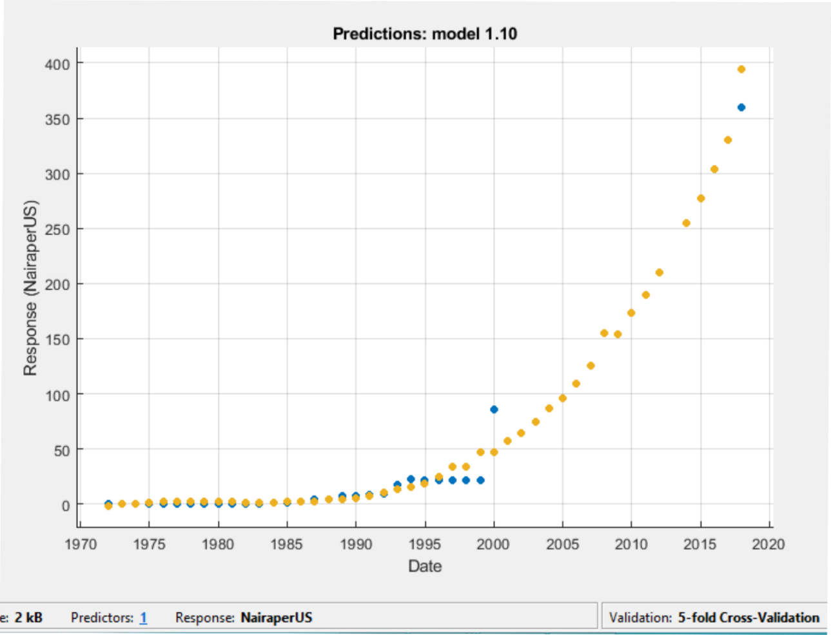

**Fig. 6. Image: Depicting Projected Naira per US Dollar against years 1970 to 2020.**

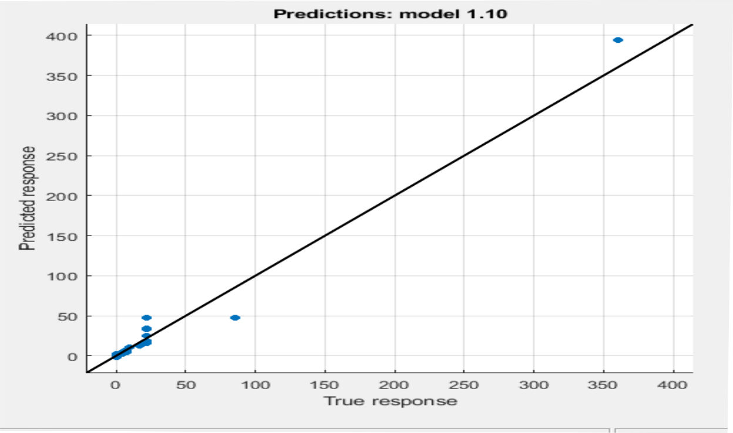

**Fig. 7. Image: Depicting Naira against the dollar on a Predicted vs. True Response.**

**5.0.2.** **Predicted Vs. True Response**

Generally, Predicted vs. True Response evaluates the model performance. It demystifies how well the regression model makes predictions for different response values. It should be noted here that a perfect regression model has a predicted response equal to the true response, thus all the points lie on a diagonal line. The vertical distance from the line to any point is the error of the prediction for that point. An excellent model might have small errors, thus making some points as predictions scattered near the line. In this case, we see the blue dots all around the intercept, all littered around zero (0). This indicates an appreciable accuracy of this mathematical model.

|  |  |  |
| --- | --- | --- |
|  |  |  |

**Fig. 8. Image: Depicting Residuals plot of Naira against the dollar.**

**3.1. Residuals Plot:**

Typically assesses the model performance. A perfect model has points or observations littered approximately and evenly distributed around 0.

Support Vector Machines or Models behave on the principle of decision intercepts that keep information boundaries. These intercepts split groups of data as classes or partnerships. A typical case is the selling rate and buying rate of the US Dollar in Nigeria. Here we see blue dots littered along several intercepts. If these dots tend to the middle of the intercept, it means supply of US Dollar is meeting its demands. In addition, the line also indicates limit, divisor or classification between “selling rate” and “buying rate” of US Dollar in Nigeria.

Finally, as a wrap, let’s take a look at performance of the Naira against major World Currencies using **linear regression model algorithm in Machine Learning**.

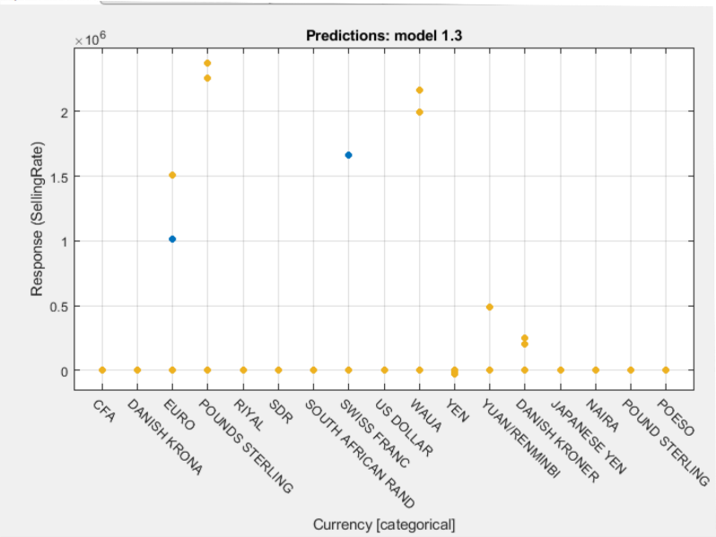

**Fig. 9. Image: Response plot of Naira against World Major Currencies.**

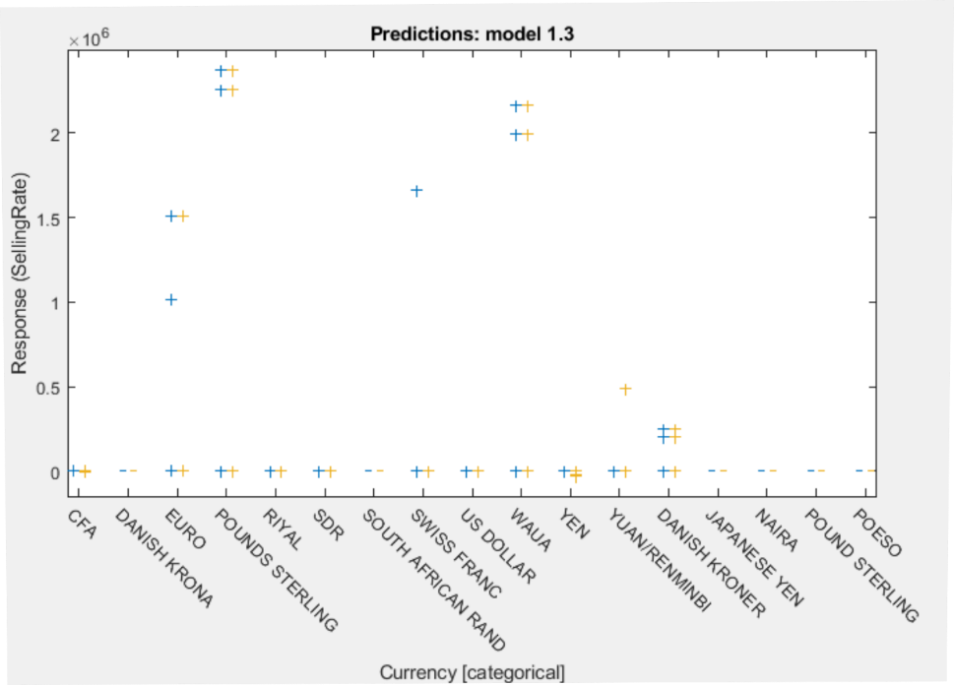

**Fig. 10.** **Image: Still within the response plot (Box Plot showing 25th and 75th percentiles)**

Over here in Fig. 10, **we see a prediction of naira depreciating against CFA, Danish Krona, Euro, Pounds Sterling, Riyal, SDR, Swiss Franc, USD, Waua, Yen, and Yuan/Renminbi, with respect to previous datasets up to and possibly beyond 2020.**

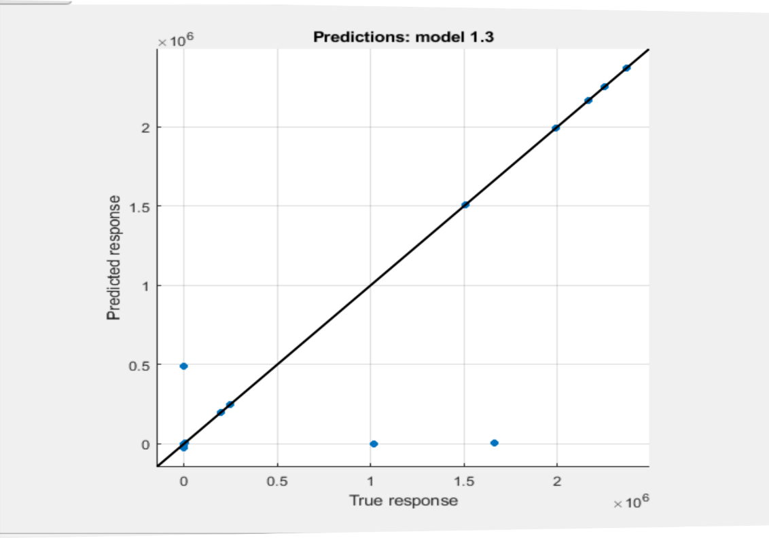

**Fig. 11. Image showing Predicted vs. Actual Plot of the Naira against World’s major currencies.**

**NB. Observe that we got similar results when comparing the Naira exchange rate to the dollar exclusively. The only difference here is that there is uniformity in on the graph of prediction as virtually all the points are laid on the intercept.**

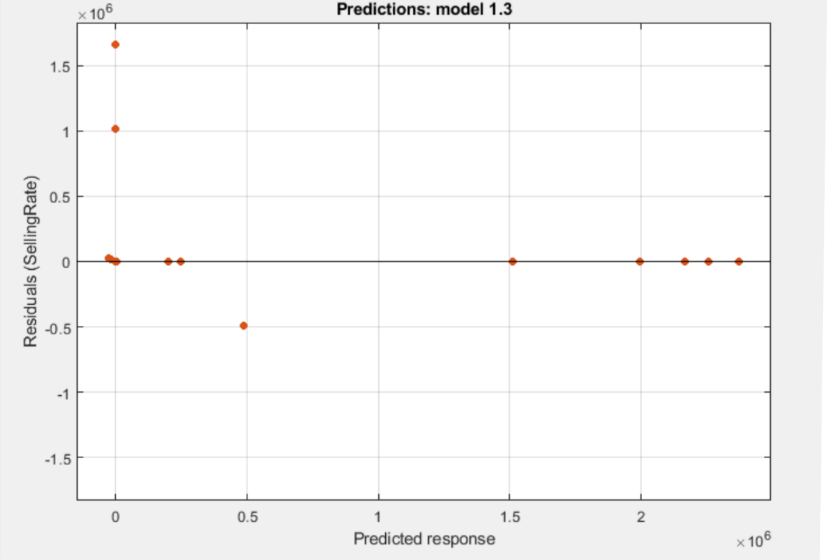

**Fig. 12. Image showing Residuals plot of the Naira against World’s major currencies.**

The above table 2 with serial numbers (S/N) one to seven (1 to 6), gives correlation analysis of January to December buying rates from 2008 to 2018 and also plots normal probability distribution curve respectively. This clearly indicates a pattern of activity that should be looked into seriously to forestall stagnation and lack of sustainability.

|  |  |
| --- | --- |
| **S/N** | **Plots/Years** |
| Fig.13-14. |  |
| Fig. 15-16. |  |
| Fig. 17-18. |  |
| Fig. 19-20 |  |
| Fig. 21-22 |  |
| Fig. 23 |  |
| Fig. 24-25 |  |
| Fig. 26-27 |  |
| Fig. 28-29 |  |

|  |
| --- |
| **Table 7. Discussion** |
| **Fig. 13-14** image shows the “selling /buying rates” [*Central Bank of Nigeria Exchange Archives*] of US Dollar in Nigeria by **demand and offer prices** in the first quarters of **2008-9** respectively in correlation. An increase in selling price is a clear indication of high demand of the United States’ Dollar by local buyers.  The pattern of buying or demand for dollar in Nigeria remains the same throughout these years with respect to Central Bank of Nigeria’s data [*Central Bank of Nigeria Exchange Archives*].  Notice how the lines fall perfectly in on the intercept or say littered all over the intercept.  Root Mean Square (RMSE) SVM for 2008, 2009 is 4.7406 and 0.1637 respectively. These numbers show how accurate the selling/buying rate class differs on the SVM model. |
| Again in **Fig. 15-16**, the correlation of “Buying/Selling rates” [*Central Bank of Nigeria Exchange Archives*] or demand for US Dollar locally as revealed by Central Bank of Nigeria for years **2010-2011** respectively. Notice the uniqueness of 2010. Years 2010, 2011 show heavy indicators of Foreign exchange spending. |
| Over here in **Fig. 17-18**, we see a continuum of “buying rates” [*Central Bank of Nigeria Exchange Archives*] from 2012 and 2013 respectively. The sparse areas along the intercept shows scarcity in foreign exchange as supply of US Dollar could not be met by Nigeria’s central Bank. |
| **Fig. 19-20**, shows 2014 and 2015 respectively and the **falling apart seen in 2014 clearly indicates that Nigeria had a huge plus in this year and should have been complete economic recovery** for the country but what happened? Non consolidation, sustainability of gains can have dire consequences. The year 2015 reflected the gross mismanagement of Nigeria’s National Income as the country was plugged back in scale. |
| **Fig. 21-22**, shows 2016 data was as a result of lack of sustainability of the gains in 2014 which immediately showed indicators in the succeeding year. Nigeria’s exchange rate to the dollar plummeted seriously to the glare of all. Naira recorded its highest depreciation in 2016 and 2017 and  2017 plunged back Nigeria’s economy into deep uncertainty. |
| **Fig. 23**, 2018 January to October “Selling/Buying Rates”.  [1] Over here we see some kind of slight improvement compared to previous years where the dots all fall perfectly or littered in line. However, the pattern reveals a slow pattern of economic recovery. |
| **Figures 24 through 29**, for the benefit of doubt, plots represent normal probability distribution curves of 2013, 2014, 2015, 2016, 2017, 2018 buying rates [*Central Bank of Nigeria*]. |

Except something is urgently done, **Nigerian Naira** (N) faces a huge gloomy future up until 2020 and maybe beyond. **Purchasing power will drop, cost of living will rise, the standard of living which is already at all-time low will further plummet**. With minimum wage less than $100 USD, and an exponential population growth on yearly basis, the successive Nigerian Governments (State and Federal) need to put aside, all distractions and make the country economically, academically, and socially strong, self-sufficient to support its younger generation and scale beyond current limitations**. The current exchange rate as at September, 2018 stands at three hundred and sixty one (361) to the Naira with strong projections of further depreciating against the US Dollar. This calls for serious concern and urgent action.**

Meanwhile, reliable information from Nigeria as at **July, 2018** informs that the country’s National foreign reserve has dropped from $USD 47 billion to $43 billion. There is no justification for this kind of economic waste and constant sabotage. A critical mind would wonder what a country of just two hundred million (200,000,000) people is doing with annual budgets running into “trillions” of local currency, erstwhile half the population swarms in extreme poverty and living below two (2) dollar a day.

**It is also very pertinent to mention here of the need to revisit those years that made landmark changes to the value of Nigeria’s National currency. Redundant imports need to be halted at all costs, especially food and clothing, consumer goods that can be produced in house. If possible, blue-chip companies that produce cars, electronics should be localized or brought in for local production**, such that Nigeria’s teeming youth of under thirty (30) years can be productively engaged.

**4.0. Summary & Conclusion**

In summary of this research paper, there is a need for Nigeria to:

1. *Extremely diversify its source for foreign exchange reserve, so when an unexpected recession hits, the reserves can salvage its citizens from untold hardship or transference to other countries who definitely have theirs to carry and*
2. *Save for the rainy day.*
3. *Nigerian Leaders, particularly the elected politicians need to stop being over-excited on the huge financial potential and disposition of their elected posts, as well as existing Nigerian resources but rather, start making this country more productive than it currently is, whilst tackling corruption, diversion of public funds for private use which has rocked the country for* ***over four decades of existence****.*
4. *Nigeria has always been known to be theoretically potent, yet is lacking the reality of the same. It is high time to fully realize these potentials and sustainably scale beyond self-inflicted limits.*

**4.1. 2018 Events**

As at the time of this writing, Nigeria has concluded arrangements to swap currency [Premium Times Nigeria], with the Chinese currency. Intelligent information gathered indicates that the motive behind this is to remove the dollar as a means of exchange for goods brought from China to Nigeria, since there is more trade between the two countries. It is very imperative to state here that if the factors (enumerated in the literature review above) responsible for Naira’s depreciation against the dollar is still in place, this effort might still be futile as in time, Naira will still depreciate against the Chinese National Currency. In simple economics, an economy (Nigeria) dependent on another economy (China, etc.) for consumption will experience higher inflation if the production economy (China, etc.) experiences inflation or recession.

Stability, economic prosperity, and political stability in Nigeria plays an integral role in maintaining peace and progress not just in West Africa Sub-region, (where it has played responsible leadership roles for over twenty years) but the African continent at large.

Nigerian Government(s) and leaders also need to change their attitude to things, stop being ***stereotyped***, ***trading blames***, or being ***complacent,*** or unable to take clear cut responsibility on economic matters since this affects virtually every facet of their livelihood. Other World countries work hard to make sure they are economically strong because the potential is there. A strong **National currency** will ensure affordable *health, education, and infrastructure*, better purchasing power for Nigerians both in business and on paid jobs, making the country completely self-sufficient. Especially for the fact that there is a constant yearly exponential population growth, thereby straining existing resources.

If Health, Education and Infrastructural development has to be secured for the Country, and its future generation, then **accountability, rich, diverse and sustained foreign exchange earning methods need to be developed and sustained**.

Furthermore, Nigeria’s economic turmoil has had a great history and impact indeed. The reason why her citizens keep attempting dangerous voyages through the Mediterranean to Europe, as well as being used as International vices of corruption is directly linked to harsh economic conditions in the country. Not to mention violent militancy by aggrieved parties in different parts of the country.

**Therefore, for these to stop, there has to be serious, concerted efforts from all stakeholders, with all hands on deck to place this country back on track.**

Who knows, perhaps if the Nigeria’s economic strengths have fully materialized and sustained, Africa might have won the **Fifa World cup** several times over.

Many Nigerians often argue that it is good to **devalue national currency**, since there are other countries in the World whose currencies are devalued yet they are doing well, maybe this is why Nigeria is yet to wake up to the reality at hand. However, quality research and economic facts have shown that this ideology or belief is false. Any country whose national currency depreciates against other international currencies always experiences high rate of unemployment, uncontrolled inflation, imbalance of trades, huge debt just to mention a few. These are known and established Facts and figures.

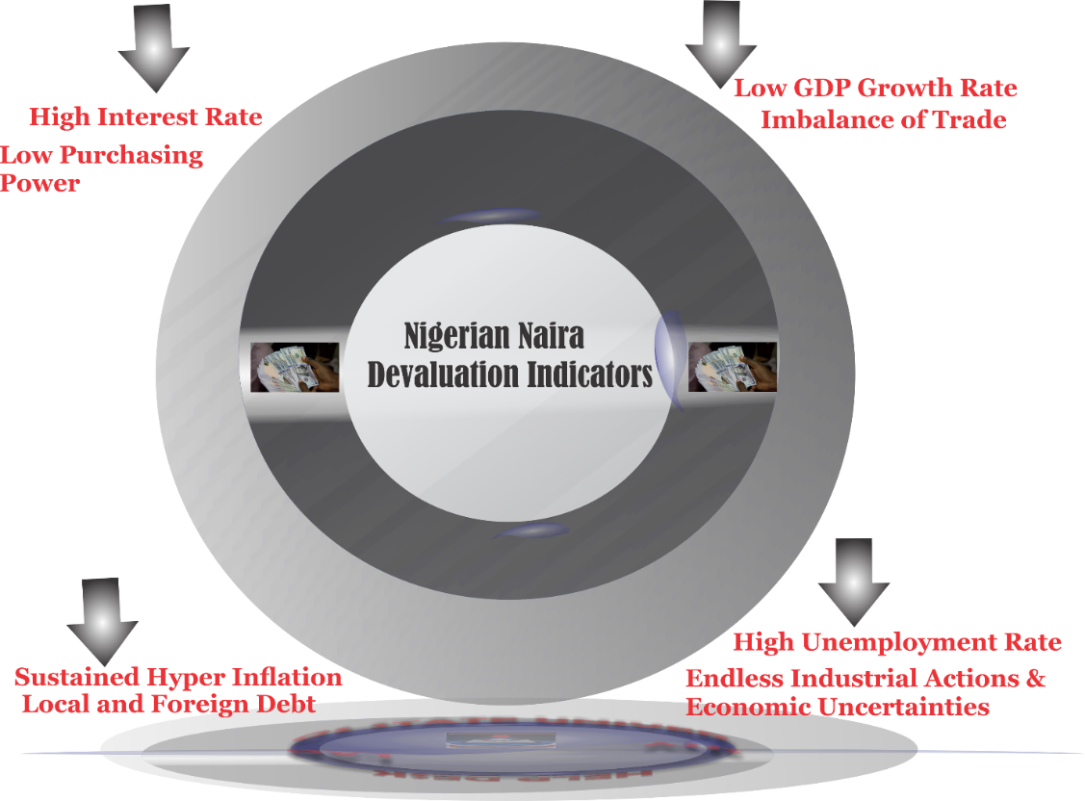

**Figure 30: Showing impacts (Indicators) of Depreciating a National Currency.**

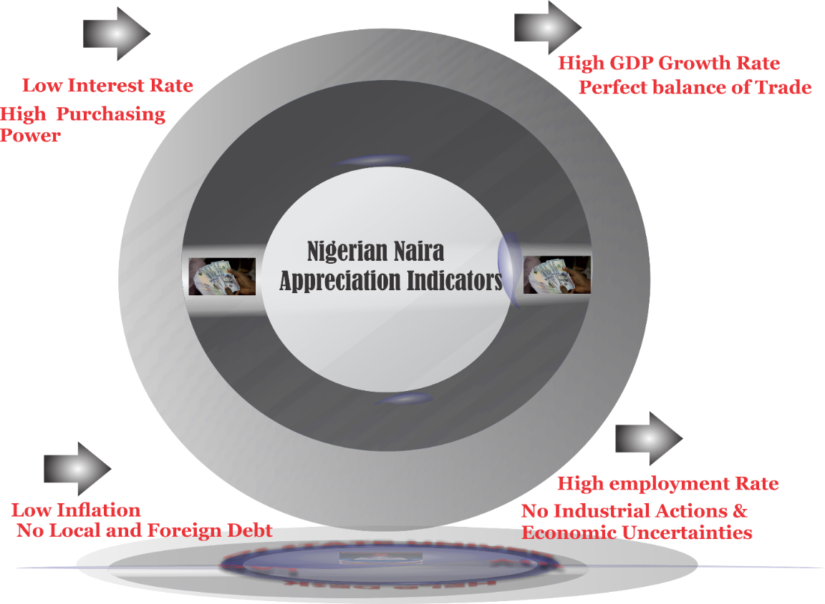

**Figure 31: Showing impacts (Indicators) of Appreciating a National Currency.**

Singapore, a South Eastern Island of Malaysia, is a model economy that has sustained economic growth. The National currency exchanges at about 1.35 to a U$D. Their economic indicators are